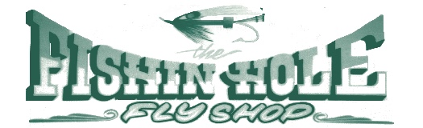

EQUIPMENT

All of our rentals include Life Jackets, Paddles & Shuttle

PLUS!! An Ice Chest, Dry Bag & Water Guns at no additional cost!

* We offer QUALITY RAFTS ranging in size from our 12’ / 2-4 person, to as large as our 15’ RAFT that holds up to 12 people!!
* Our STAR INFLATABLE KAYAKS are perfect for one or two people, or a group of people who want to be the captain of their own boat!
* Single person PONTOON BOATS are the perfect watercraft for a day of fishing as well as our 14’ FRAME RAFTS, complete with Oars & an Anchor.
* We also rent all of the EQUIPMENT listed individually, for those of you who may just need a thing or two for the day.

Fly Shop

Raft Rentals

541-878-4000

Deli

Gift & Yarn

541-878-4003

Rafting the Upper Rogue River is an Unforgettable Experience!

There’s a mix of exciting class I & II rapids as well as sections in-between where you can just kick back and soak in the beautiful scenery or stop at one of the many popular areas to swim and visit with other rafters!

21873 Hwy 62 Shady Cove, OR 97539

[www.thefishinholeflyshop.com](http://www.thefishinholeflyshop.com)

PRICE CHECKING? GIVE US A CALL! NO HIDDEN FEES!

One thing to keep in mind when price checking is that some places can be misleading. They may have a base price for say a certain size of Raft but they may not mention that there is an extra fee for additional people or equipment.

All of our rentals include extra equipment without the extra charge!

* GROUP RATES AVAILABLE
* RAFTER’S LUNCH SPECIALS
* SPECIAL CUSTOMER CARD
* CALL FOR PICK UP AT RAMP
* CALL IN LUNCH AHEAD
* FRIENDLY CUSTOMER SERVICE